**WHOO RU CHatbot**

Seal Team Five

Rowan University  Rev. 1.0

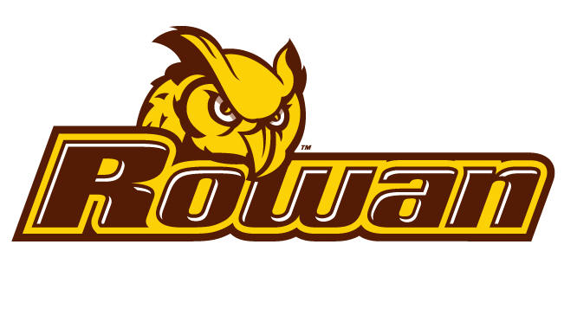

# Table of Contents

Table of Contents 1

Infrastructure and Framework 2

# Infrastructure and Framework

1. Framework - The Whoo chatbot will use API.AI as it’s chat framework.
2. Interface - The Whoo chatbot will be presented through a web interface accessed through a hosted web server.
   1. Web Service
   2. AWS will host the server
   3. Web server will be an EC2 instance running Apache
   4. Server will be publicly accessible at <http://52.41.96.243/>
   5. SSH access will only be available from elvis.rowan.edu
   6. Access will require a private key file (whoo.pem)